Networking and Cyber Security

Journal 1

Name: Archana Kumari Lama

Student ID: 12199907

# Week 1 Tutorial

In week 1 tutorial, familied with Linux, PowerShell and GitHub in order to execute given commands. Here we have executed several command like to get the IP address, route, ping, lookup and so on. Below are the screenshots of the commands and the outputs.

PowerShell Command execution

Get-NetAdapter

Gives information of adapter

Test-Connection- It gives the ip address.

Trace route

Test-NetConnection: Helps to connect with Linux

Nslookup

GetNet-Neighbour

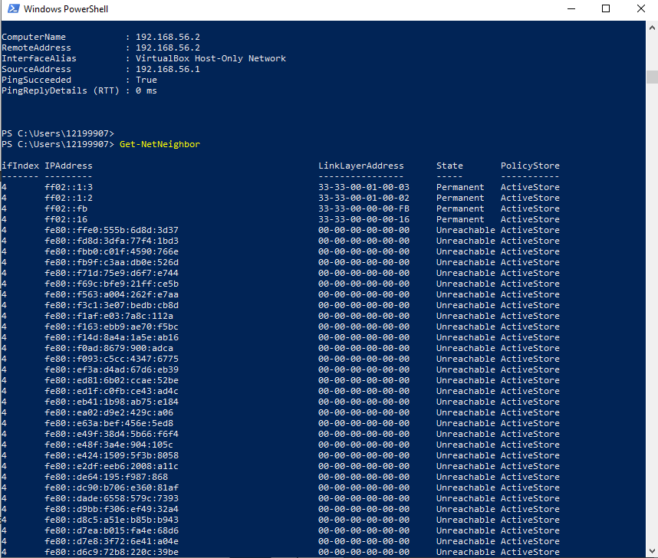

ARP- gives the mac address

NetRoute

# Tutorial 2

In week two, the main objective was to capture the packets in Linux. Here, to capture packets we ping to the Linux i.e. OpenWRT from PowerShell.

Below are the steps to capture the packets:

* Open Linux i.e. OpenWRT
* Enter the command “tcpdump -I eth0 -n -w ping1.pcap ‘arp or icmp’ “ in Linux.
* Now, enter the command “Test-Connection 192.168.56.2 -Count 10” in PowerShell.
* After receiving 10 counts in PowerShell we enter another command “ls-l ping1.pcp”

*This helps to capture the packets.*

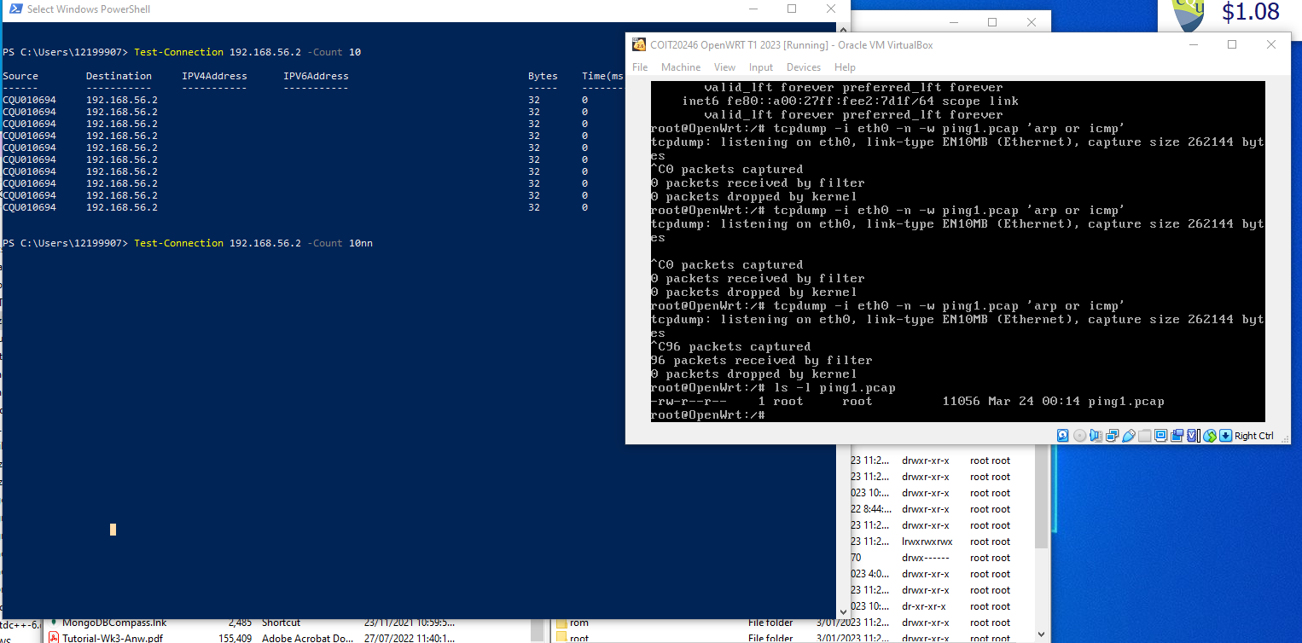

* Once packets are captured, we transfer to the windows with the help of FileZilla.
* Open FileZilla from the c drive and drag and drop the ping1 to the desktop.

* Open the packets “Ping1”.

* Track the Request and Reply of ICMP.

Here, we captured 72 bytes.

# Week 3

Task 1

ARP is a protocol to map the mac address to the IP address.

Here it displays all the mac address and IP address.

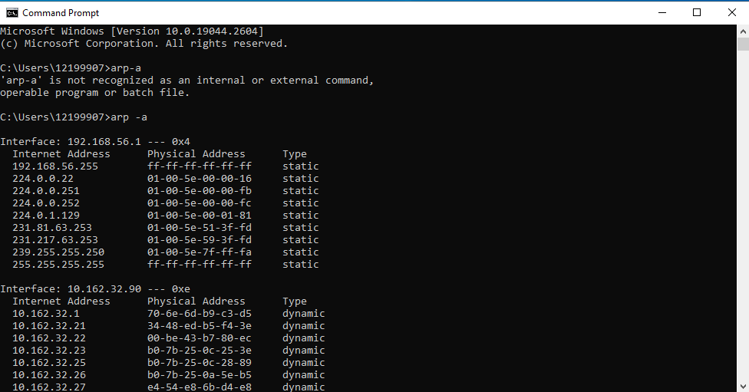  
  
Here, with in the network we can ping the address or else we cannot ping.

Task 2

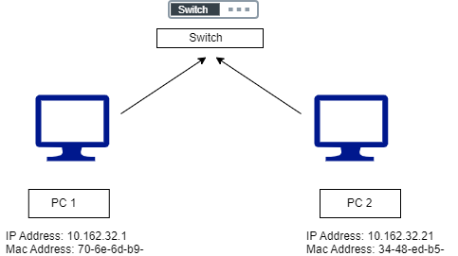

c.

The purpose of the ARP address is to be used by sending device to convert IP address to MAC address. ARP packets also used when two system needs to connect.

The ARP are sent by the host who does not know the MAC address to know the MAC address.

d.

|  |  |
| --- | --- |
| Destination Address(6 Bytes) MAC address: 0a:00:27:00:00:0a | |
| Source Address(6 Bytes) MAC address: | |
| Type 0 (2 bytes) | Checksum (4 bytes) |
| Data | |

Figure: Packet Diagram for 1st ARP packet

e.

The first two packets of ICMP has request and reply. IT has two source IP address i.e 192.168.56.1 and 192.168.56.2 with the total length of 74 bytes. Here, the version of internet protocol is 4 and the length of header is 20 bytes in each ICMP.

f.

|  |  |  |
| --- | --- | --- |
| Type (8) | Code (0) | ICMP CheckSum |
| Identifier(0) | Sequence Number | |
| Data(32 bytes) | | |

Fig: Packet Diagram for first ICMP packet

Task 3

b. In this design, there are 4 old camera and 6 new camera. They both are used for the capturing the pictures and the videos. Four old camera is connected to the old switch where as new camera is connected to new switch. The power supply is same for the both switches.

In this design there is two separate switches which helps to connect the two diffent model of cameras in order to give a good functioning. This helps the camera to function more effectively in respective mode.

c.

|  |  |
| --- | --- |
| Switch | 1 with 6 port |
| New Camera | 4 |
| Power Point | 1 |

Task 4

I believe Linux is one tool that can be useful outside of this unit. Linux is an open source operating system. It is a secure operating system and easy to access and operate. In Linux we can write any command to access the IP address of the system and also to connect to the other system.